**What is Site Builder?**

It is an easy-to-edit platform that enables anyone, even without technical knowledge, to build and publish a website on the Internet. With the drag and drop system allows easy editing of images and texts with a few clicks the platform allows the insertion of maps, videos, forms, slide show of images and products.

**How do I access Terra Site Builder?**

Access to the Site Builder is through its [Control Panel.](http://painel.terraempresas.com.br/Login.aspx) Access the control panel using your **login** and **password:**:

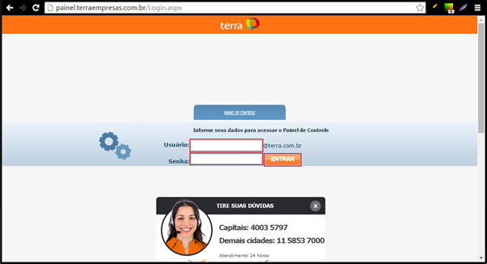

Once logged into your dashboard, click **"Hosting/Site Builder"**  and **"Access Now":**

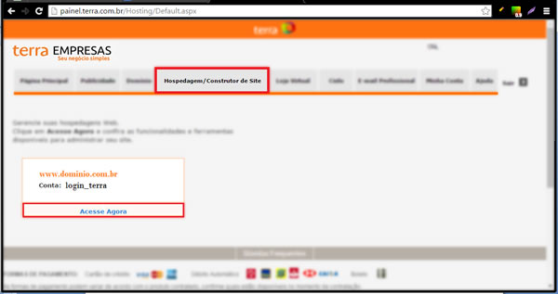

You will be directed to the control panel of your Hosting/Builder. On the home page, click **"Create Site"**within the **"New Builder"** option:

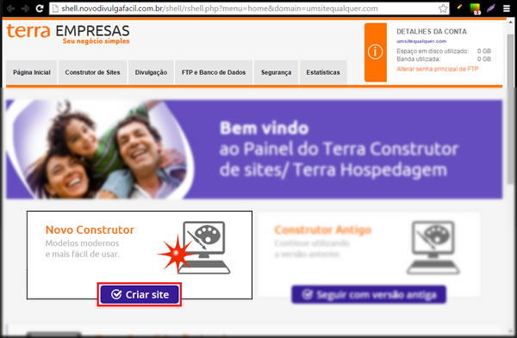

Click **"Start".**

**IMPORTANT:** If your browser has a Pop-up blocker, turn it off before you **start.**

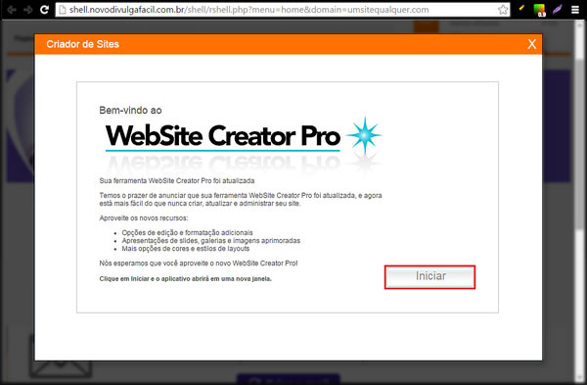

If this is your first access to the Site Builder, you will need to click **"Install"** for the service to be available in your account.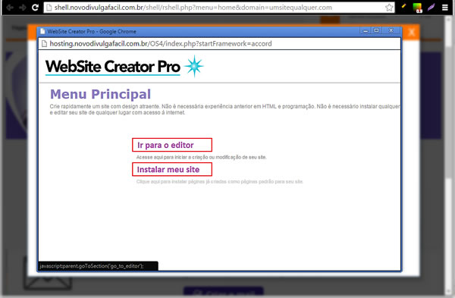

After, click **"Go to editor."**

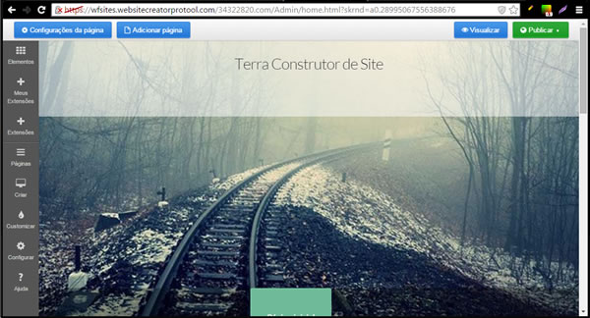

**How do I add and edit an element?**

Click the elements in the left pan:

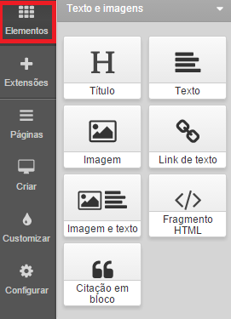

Drag the element type over the page and release when a blue bar appears where you would like to insert the element:

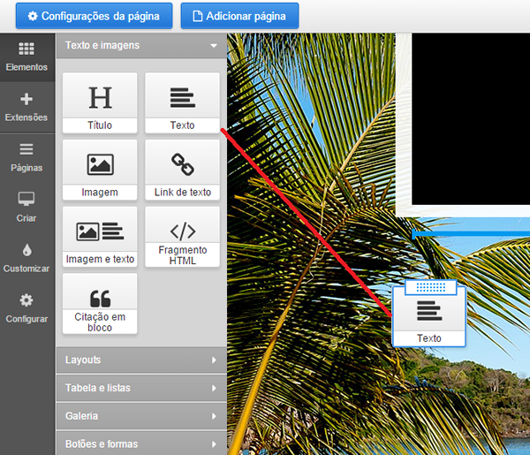

For text elements a text placeholder will be added, click to edit that on the right side will appear the available text formatting:

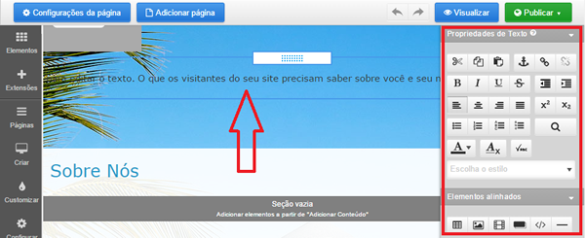

For image elements the right pan tray will open with the **Add Image**control, drag and drop an image over the control, or click the control to load manually:

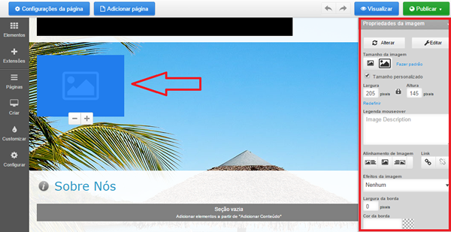

**How do I add a new page?**

To add new pages, simply go to the 'Pages', which is in the side menu of your editor. You can identify it with this icon:



Clicking on it will appear the options of this section, where this button is located:



Click on it and you will open a box: Here is where you must select which format will be used to create the new page*(the Category format appears only for online store accounts)*and also fill in its name, in the following field: Among the page formats we offer, you can choose between Institutional, Category, Gallery, Contact or White. Keep in mind that even if you choose a page format, you can edit it however you want, deleting or modifying each of its elements.

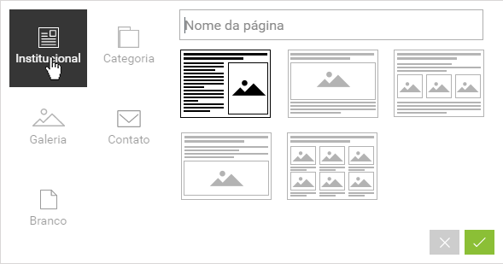



**How do I add or remove additional page elements?**

These elements can be added or removed from pages individually at any time and may vary depending on the layout and design of the site:

I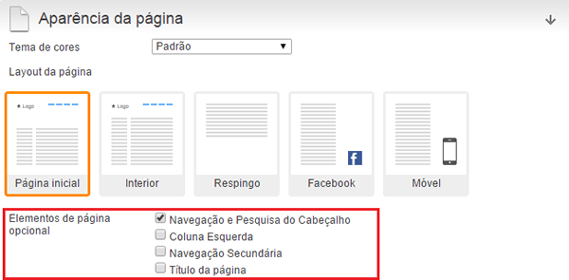

## How do I set the layout of the page?

First let's understand what Layout is and that's pretty simple. It is the template for each of your pages, be it the home or an internal page. That is; is the structure of the page. The arrangement, layout, design, design. Whatever you want to call it.

Therefore, we need to understand that there are two ways to change the style/layout of your pages:

* - Editing the layout at once (which we will see in this post);
* - Editing part by piece.

Here's the Tip: Of course, if you want to edit in more detail, you'll have to edit it piece by piece. But who knows how to give an updated look of a very well-known store, can be done without any problem with the change of layout.

To edit the page layout at once, go to the menu(the option exists only for accounts with online store, so if you have an institutional site it will not appear in themenu):

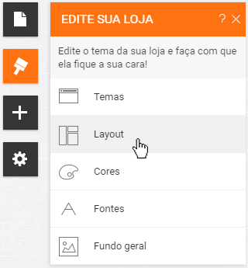

And soon you'll see some layout options: It's important to consider a few points:

* - Take a good look at each drawing and imagine what your page will look like.
* - Learn more about the tool: see that each layout model is made up of elements that have icons. Each icon represents a type of thing: image, category, slideshow, products, etc. If you want to know better the icons/types of elements, go to the + button (it's another menu) and recognize the icon that takes each type of element.
* - If you add a layout that has elements that - currently - your page in question does not have, it will be grayed out. You will have to add it or delete it.
* - Everything that the layout automatically adds to your page can be changed or deleted, it's just a template/idea we offer.

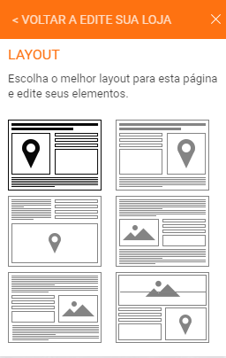

## How do I delete a page in my Site Builder?

To delete a page go to your editor's Pages option:



In this option, you'll see the list of the default pages. To delete one of the pages, click on the configuration gear, which will appear when you take the mouse cursor to the name of one of the pages:

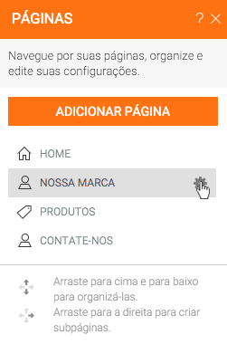

Clicking on the configuration gear will open a box like this:

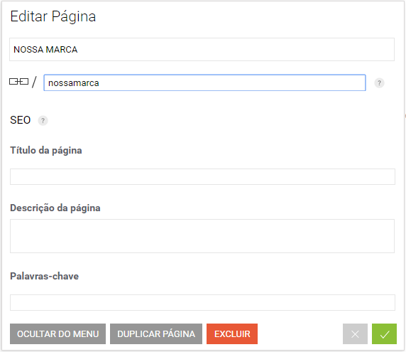

See that one of the buttons is **Delete.** Click on it and the page will be deleted.

If you prefer, just hide the page so you can use it again in the future.